Consumer takeaway
Blog Category | Housing Market
Tag | Luxury, National, Housing Affordability
URL | https://www.redfin.com/news/luxury-housing-market-april-2026
Link to Data Source | https://docs.google.com/spreadsheets/d/1qLpR_jc9mzK2Vqe0m5zakGuU0OBFlo90ZDsJtzrWx54/edit?gid=2062152078#gid=2062152078  https://us-west-2b.online.tableau.com/#/site/redfinrent/workbooks/2224674/views
Suggested social media copy
PR Strategy

Luxury Home Prices Rise Amid Uptick in High-End Homebuying and Selling
- The median luxury sale price is up 4% year over year—more than double the gain in non luxury prices.
- Luxury pending home sales are also up 4%—the biggest increase in over a year. San Francisco’s luxury market is booming, with sales up nearly 50%—the most in the nation.
- Rising demand and prices are buoying luxury new listings, which are rising more than twice as fast as non luxury listings.

The median U.S. luxury home sale price rose 3.6% year over year to $1.39 million during the three months ending April 30—more than double the 1.4% gain in non luxury sale prices.
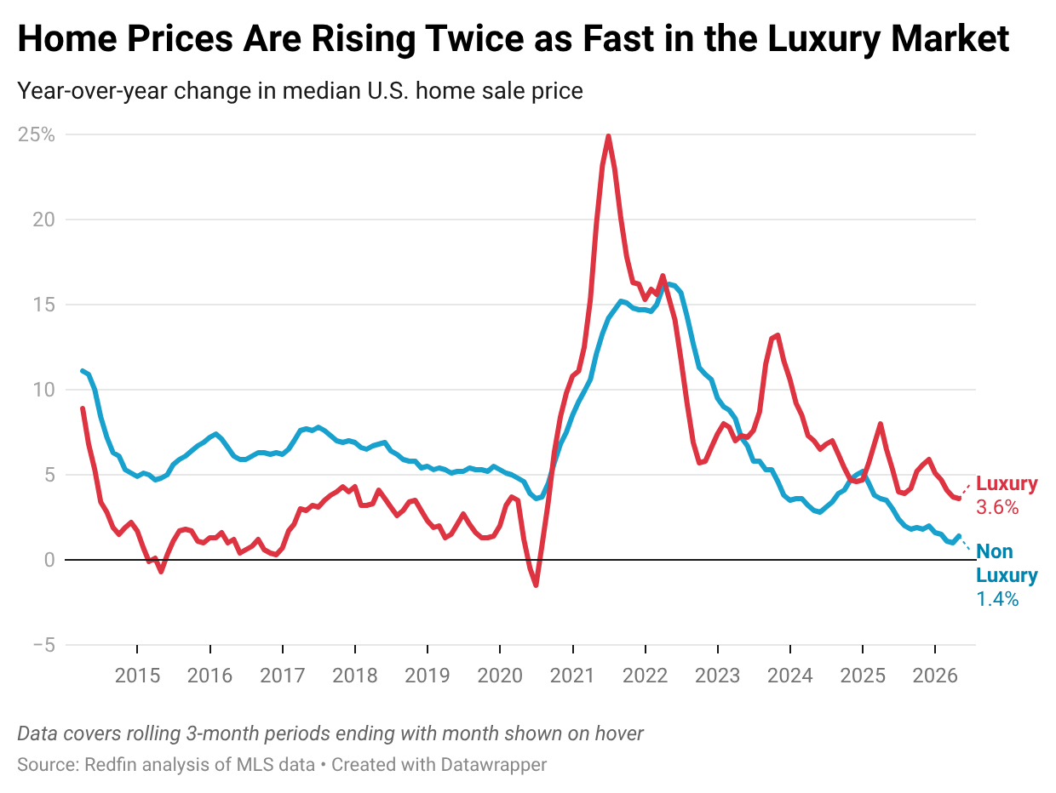
Luxury prices are on the rise as demand for luxury homes increases. Pending sales of luxury homes jumped 4.3% year over year—the largest gain since January 2025. That’s slightly larger than the 4% gain in non luxury pending sales, which was the biggest since December 2024. Homebuyer demand has generally been climbing thanks to an improving job market and a decline in mortgage rates last month, though rates have been more volatile in May.
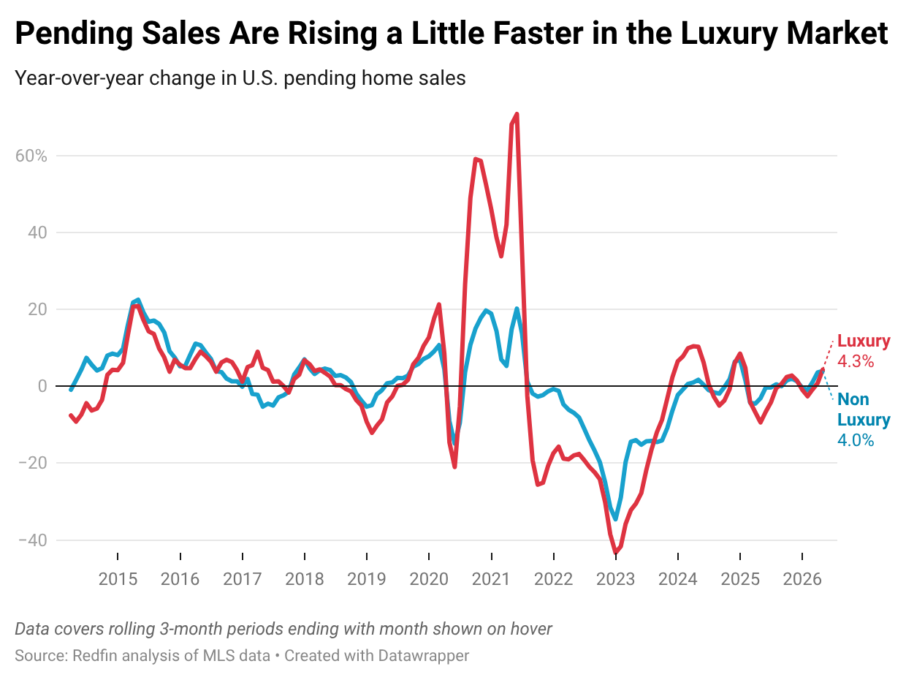
Stacey Bryant, a Redfin Premier real estate agent in Boston, noted that luxury buyers are typically less sensitive to mortgage-rate swings than non luxury buyers, which may be one reason the luxury market is holding up relatively well.

“When I have a buyer looking at a home above $1 million, interest rates and geopolitical uncertainty don’t matter as much,” Bryant said. “They want to buy a home and have the means to do it, so a 6.3% mortgage rate versus a 6.1% mortgage rate doesn’t really make a difference.”

No metro Redfin analyzed saw a larger gain in luxury pending sales than San Francisco, which posted a 48.4% year-over-year increase in April—the largest since June 2021. San Francisco’s housing market has been on the upswing thanks to the AI boom, which has landed many workers with hefty paychecks and bonuses.

The uptick in luxury home prices and demand in many parts of the country is likely incentivizing more high-end homeowners to put their houses up for sale. New listings of U.S. luxury homes climbed 2% year over year during the three months ending April 30, compared with a 0.6% gain in non luxury new listings. San Francisco saw the second largest gain in new listings.
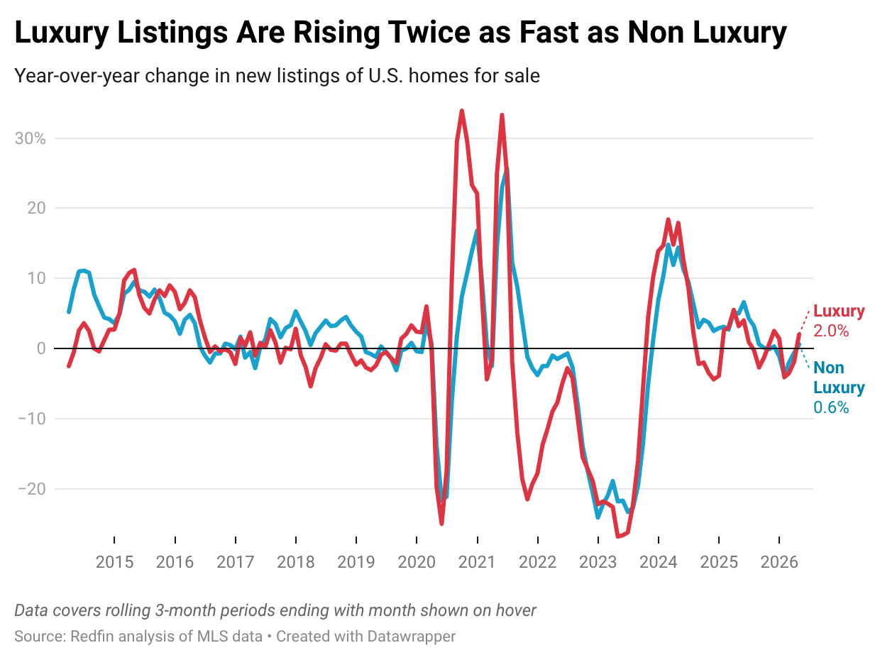

This report is based on a Redfin analysis of MLS data that is subject to revision. All figures cover rolling three-month periods. Redfin defines luxury homes as those estimated to be in the top 5% of their metro area’s price range, while non-luxury homes fall into the 35th–65th percentile.

Luxury Market Summary: Three Months Ending April 30, 2026
 | Luxury | Non Luxury
Median sale price | $1,388,230 | $377,734
Median sale price, YoY change | 3.6% | 1.4%
Pending home sales, YoY change | 4.3% | 4.0%
Homes sold, YoY change | 0.8% | 1.6%
New listings, YoY change | 2.0% | 0.6%
Active listings, YoY change | 1.4% | 2.3%
Median days on market | 60 | 51
Median days on market, YoY change | 6 | 5

Metro-Level Luxury Highlights: Three Months Ending April 30, 2026
Redfin’s metro-level luxury data is based on an analysis of the 50 most populous U.S. metropolitan areas. All changes below are year over year.
- Prices: Luxury prices rose most in Tampa, FL (17.1%), Las Vegas (16.1%) and Kansas City, MO (15.2%). They fell in just four metros: Detroit (-2.4%), Cincinnati (-1.6%), New York (-0.6%) and Denver (-0.6%).
- Pending sales: Luxury pending sales rose most in San Francisco (48.4%), Tampa (35.8%) and West Palm Beach, FL (15.8%). They fell most in Nassau County, NY (-27%), Minneapolis (-15.9%) and Seattle (-14.4%).
- Closed home sales: Luxury home sales rose most in San Francisco (43.2%), Tampa (42%) and Kansas City, MO (24.8%). They fell most in Cincinnati (-22.8%), Seattle (-20.8%) and Anaheim, CA (-19.9%).
- New listings: Luxury new listings rose most in Warren, MI (26.6%), San Francisco (17.7%) and St. Louis (15.2%). They fell most in Miami (-16.7%), New York (-13.7%) and Orlando, FL (-13.7%).
- Active listings: Luxury active listings rose most in Detroit (22.8%), Seattle (16.1%) and Atlanta (15.4%). They fell most in Anaheim (-24.2%), New York (-18.3%) and Miami (-15.5%).
- Median days on market: In Pittsburgh, the typical luxury home that went under contract did so in 64 days, down 17 days from a year earlier—the biggest decrease among the metros Redfin analyzed. Next came Austin, TX (-16) and Tampa (-14). The biggest increases were in New York (33), Las Vegas (31) and Philadelphia (18).
Full Metro-Level Luxury Data: Three Months Ending April 30, 2026
U.S. metro area | Median sale price | Median sale price, YoY change | Pending sales, YoY change | Homes sold, YoY change | New listings, YoY change | Active listings, YoY change | Median days on market | Median days on market,YoY change
Anaheim, CA | $5,375,518 | 1.9% | -13.4% | -19.9% | -13.5% | -24.2% | 52 | -11
Atlanta, GA | $1,430,613 | 4.8% | 3.0% | 2.3% | 11.2% | 15.4% | 44 | 0
Austin, TX | $1,829,754 | 8.6% | -3.0% | -5.9% | -10.3% | -7.5% | 57 | -16
Baltimore, MD | $1,294,453 | 3.3% | -13.2% | -6.6% | -7.7% | -6.2% | 43 | 18
Boston, MA | $2,861,709 | 5.9% | -8.6% | 0.3% | -4.5% | -2.4% | 34 | -7
Charlotte, NC | $1,618,146 | 1.7% | -3.9% | -10.8% | 6.1% | 8.7% | 54 | 12
Chicago, IL | $1,540,770 | 6.4% | 11.4% | -1.7% | -8.8% | -14.4% | 48 | -12
Cincinnati, OH | $929,965 | -1.6% | -1.2% | -22.8% | 1.6% | -1.9% | 48 | 1
Cleveland, OH | $832,252 | 10.4% | 2.6% | 5.0% | 13.4% | -0.3% | 32 | 0
Columbus, OH | $1,006,712 | 0.1% | 3.6% | -6.1% | 7.2% | 4.1% | 38 | -7
Dallas, TX | $1,601,151 | 0.3% | 8.6% | 0.2% | 6.3% | 8.4% | 47 | 10
Denver, CO | $1,907,321 | -0.6% | 0.8% | -4.9% | -3.3% | 3.3% | 24 | 0
Detroit, MI | $719,937 | -2.4% | 0.0% | 13.8% | 6.0% | 22.8% | 20 | 8
Fort Worth, TX | $1,286,738 | 8.0% | 4.6% | 13.6% | -5.7% | -2.4% | 51 | 6
Houston, TX | $1,335,547 | 3.5% | -5.6% | -4.9% | -2.9% | 0.4% | 40 | 13
Indianapolis, IN | $1,005,871 | 9.5% | -3.3% | -3.5% | -3.3% | -5.6% | 29 | 6
Jacksonville, FL | $1,576,271 | 3.2% | 9.6% | 4.2% | -4.1% | -10.1% | 59 | 7
Kansas City, MO | $1,145,851 | 15.2% | 0.4% | 24.8% | 14.8% | -2.8% | 48 | 1
Las Vegas, NV | $1,734,559 | 16.1% | -5.0% | -14.3% | -13.2% | -1.9% | 97 | 31
Los Angeles, CA | $4,466,395 | 7.7% | -8.2% | -14.1% | -10.3% | -12.7% | 60 | 4
Miami, FL | $4,957,799 | 12.8% | 15.1% | 11.8% | -16.7% | -15.5% | 142 | 16
Milwaukee, WI | $1,127,948 | 7.4% | 6.9% | -4.7% | 0.6% | -7.3% | 65 | 17
Minneapolis, MN | $1,282,452 | 6.1% | -15.9% | -19.8% | -1.4% | -0.8% | 55 | 8
Montgomery County, PA | $1,560,728 | 10.9% | -5.2% | -10.0% | 8.1% | 9.0% | 43 | 9
Nashville, TN | $2,241,809 | 8.1% | 4.7% | 1.0% | 10.0% | 9.2% | 118 | 17
Nassau County, NY | $2,789,005 | 10.8% | -27.0% | -9.8% | -9.0% | -10.9% | 93 | -5
New Brunswick, NJ | $2,048,293 | 0.4% | -1.1% | -14.2% | 2.3% | 0.8% | 40 | -7
New York, NY | $4,253,303 | -0.6% | -4.4% | -11.7% | -13.7% | -18.3% | 101 | 33
Newark, NJ | $2,060,354 | 6.6% | -3.6% | -18.8% | -3.7% | -9.3% | 19 | -1
Oakland, CA | $3,065,363 | 2.3% | 1.7% | -1.9% | -2.8% | -11.8% | 10 | -1
Orlando, FL | $1,455,361 | 5.6% | -10.1% | -14.3% | -13.7% | -10.6% | 48 | 5
Philadelphia, PA | $1,385,825 | 13.5% | 4.0% | -2.8% | -4.3% | -4.5% | 66 | 18
Phoenix, AZ | $2,190,814 | 9.5% | 6.9% | 4.3% | -3.6% | 1.6% | 66 | 2
Pittsburgh, PA | $880,011 | 3.9% | -2.4% | -2.7% | 3.6% | 4.4% | 64 | -17
Portland, OR | $1,448,648 | 0.5% | 3.5% | 16.5% | 10.0% | 0.2% | 43 | -2
Providence, RI | $1,726,389 | 9.7% | -10.0% | -6.7% | -9.4% | 0.6% | 53 | 17
Riverside, CA | $1,703,954 | 0.7% | -6.6% | -9.0% | -12.8% | -12.3% | 63 | -2
Sacramento, CA | $1,691,923 | 2.0% | 14.1% | 5.8% | 10.7% | 8.3% | 40 | 0
San Antonio, TX | $987,731 | 5.6% | -4.5% | -17.0% | 1.4% | 0.0% | 93 | 2
San Diego, CA | $3,771,836 | 0.9% | 8.8% | 11.3% | 0.8% | -6.6% | 43 | 8
San Francisco, CA | $6,738,794 | 9.6% | 48.4% | 43.2% | 17.7% | -10.3% | 12 | -1
San Jose, CA | $5,650,933 | 2.5% | 6.9% | 2.2% | 1.7% | -9.7% | 10 | 1
Seattle, WA | $2,953,926 | 0.3% | -14.4% | -20.8% | 11.8% | 16.1% | 11 | 5
St. Louis, MO | $1,031,637 | 13.0% | 5.2% | 6.1% | 15.2% | 13.0% | 17 | -10
Tampa, FL | $1,670,163 | 17.1% | 35.8% | 42.0% | 9.7% | 10.3% | 20 | -14
Virginia Beach, VA | $1,120,585 | 9.1% | -10.0% | -10.0% | 13.2% | -4.0% | 51 | 11
Warren, MI | $1,073,544 | 8.4% | 5.9% | -9.2% | 26.6% | 12.5% | 34 | -1
Washington, DC | $2,039,624 | 2.2% | 5.3% | -2.3% | 5.0% | 3.4% | 33 | 3
West Palm Beach, FL | $4,502,311 | 4.7% | 15.8% | 1.7% | -5.7% | -5.4% | 100 | 7
United States of America | $1,388,230 | 3.6% | 4.3% | 0.8% | 2.0% | 1.4% | 60 | 6

